**Exercise: Applying design fundamentals in Figma**

**Overview**

This exercise will cover the steps from wireframes to high-fidelity mock-ups and apply design fundamentals using the brand style guide, which specifies every aspect of the look and feel of the brand. This includes typefaces, colors, and how pictures and images should be used. It also includes a UI kit, a set of files containing critical UI components like font sizes, icons and documentation. A Figma file of the wireframe used in this exercise and an image resource folder is provided below.

[Applying design fundamentals in Figma - Wireframe](https://d3c33hcgiwev3.cloudfront.net/ICdLWb5gTE-m-IBTHUbNKA_1b4d05e13f71491396e9e67699bc82e1_C8.M1.L3.Item-3-Exercise-Wireframing-the-project-Wireframe.fig?Expires=1723766400&Signature=K7ijnYykk6Lli3viD-sETLz-DRDyJGMJqbPgxfFT7Gls2LptGBoL0YHovc1RQJg1~4e9z~AAOPCcfTlGKhwCTTWtvFMx0VzGLZXp8WXZBTXP4UIlum8vg-UPy9JXwfywVhbzZL2dpoje8l0WezDpRFpjDARYE8Pejov0HNvZ-r8_&Key-Pair-Id=APKAJLTNE6QMUY6HBC5A" \t "_blank)

[FIG File](https://d3c33hcgiwev3.cloudfront.net/ICdLWb5gTE-m-IBTHUbNKA_1b4d05e13f71491396e9e67699bc82e1_C8.M1.L3.Item-3-Exercise-Wireframing-the-project-Wireframe.fig?Expires=1723766400&Signature=K7ijnYykk6Lli3viD-sETLz-DRDyJGMJqbPgxfFT7Gls2LptGBoL0YHovc1RQJg1~4e9z~AAOPCcfTlGKhwCTTWtvFMx0VzGLZXp8WXZBTXP4UIlum8vg-UPy9JXwfywVhbzZL2dpoje8l0WezDpRFpjDARYE8Pejov0HNvZ-r8_&Key-Pair-Id=APKAJLTNE6QMUY6HBC5A" \t "_blank)

[Applying design fundmantals in Figma - Assets](https://d3c33hcgiwev3.cloudfront.net/qbZ2Wr5jTZya6-dDlPrGwQ_5b3b588277444859a71d1c78010d06e1_Applying-design-fundmantals-in-Figma---Assets.zip?Expires=1723766400&Signature=F-jrOWYrETQYja0Y~9OGcTndm9dge7Aq2fbST7y~RI0FES8dkU7XETcQ0hXWMUEt2GWRHkDmb9EPoLcZTyBJ25blLLS8S7dTru5fkJ8tLGWw48VkhBxuNbxnf5efbel7hdiogVJ6QQ3fhhcQZWbdM9Nj6pZZGkSUhZlNb-dGSXY_&Key-Pair-Id=APKAJLTNE6QMUY6HBC5A" \t "_blank)

[ZIP File](https://d3c33hcgiwev3.cloudfront.net/qbZ2Wr5jTZya6-dDlPrGwQ_5b3b588277444859a71d1c78010d06e1_Applying-design-fundmantals-in-Figma---Assets.zip?Expires=1723766400&Signature=F-jrOWYrETQYja0Y~9OGcTndm9dge7Aq2fbST7y~RI0FES8dkU7XETcQ0hXWMUEt2GWRHkDmb9EPoLcZTyBJ25blLLS8S7dTru5fkJ8tLGWw48VkhBxuNbxnf5efbel7hdiogVJ6QQ3fhhcQZWbdM9Nj6pZZGkSUhZlNb-dGSXY_&Key-Pair-Id=APKAJLTNE6QMUY6HBC5A" \t "_blank)

On completion, you will have the skills necessary to take the wireframes of your design solution for your project on the reserve-a-table section of the Little Lemon website to produce high-fidelity mock-ups. You may wish to revise the following lesson items in the **Principles of UX/UI** course before you begin or refer to them as you go along:

* [Working with images](https://www.coursera.org/learn/principles-of-ux-ui-design/lecture/L4TiQ/working-with-images)
* [Design text hierarchy and grid](https://www.coursera.org/learn/principles-of-ux-ui-design/supplement/K2uC7/exercise-design-text-hierarchy-and-grid)
* [High fidelity design](https://www.coursera.org/learn/principles-of-ux-ui-design/lecture/FHMAO/stylize-high-fidelity-design)

**Scenario**

The owners of the Little Lemon Restaurant have approved the wireframes for their website and want you to turn these wireframes into a high-fidelity design or a design that closely resembles the final product using their brand style guide.

**Instructions**

**Step 1: Brand style guide**

* First, let’s examine the style guide provided by the owners of Little Lemon. This guide serves as a starting point.

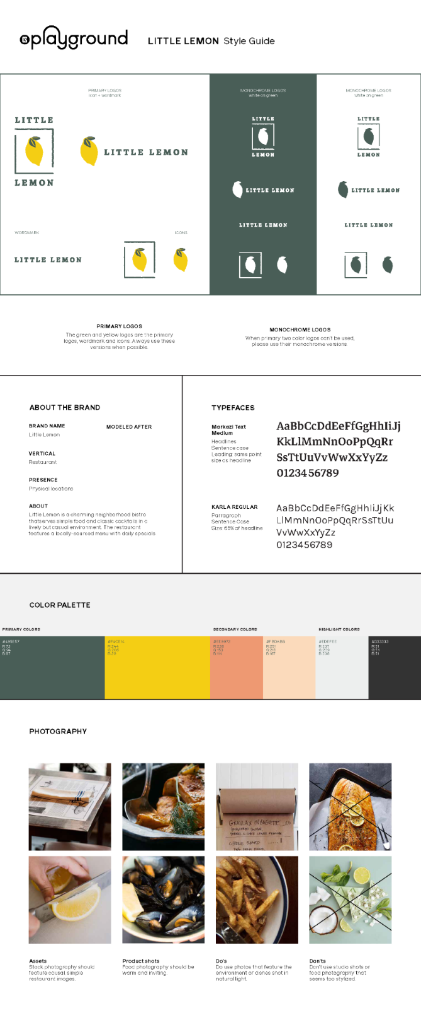

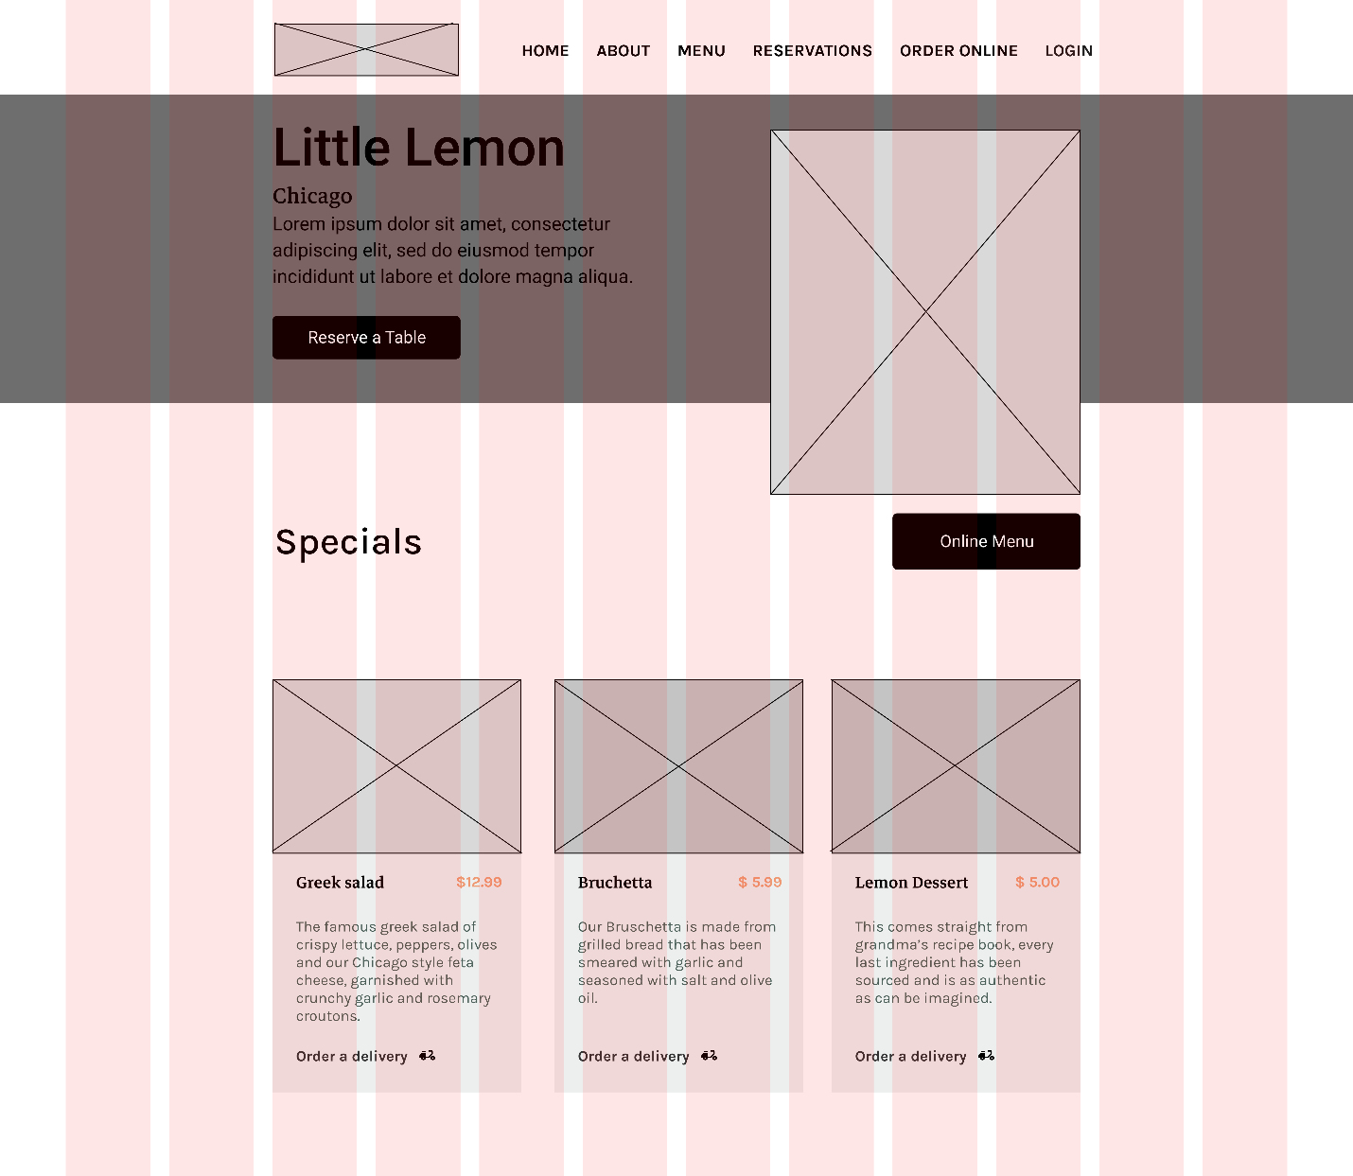

Now, let’s start with creating the styles as per the brand style guide. Styles help you simplify your workflow, keep text and colors consistent and save valuable time.

* To create a color style, follow the next steps using the Little Lemon brand colors:

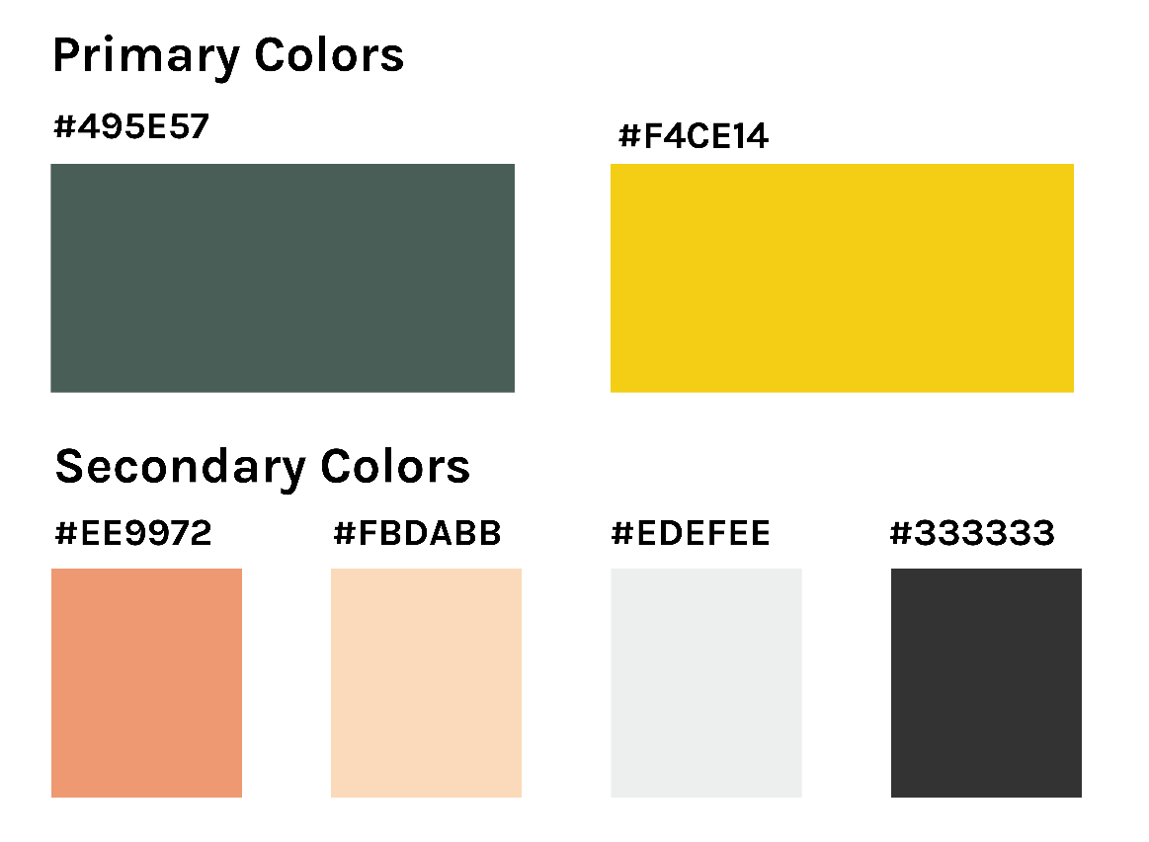

* To create text styles, follow the next steps using the Little Lemon brand text styles:

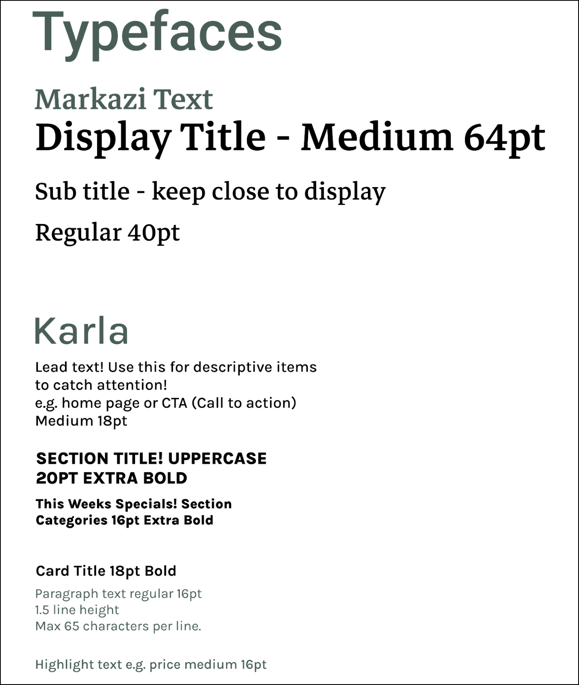

**Step 2: Add content to the placeholders on the wireframe**

* First, the Navigation bar needs a logo and the text needs to be altered.

Wireframe for navigation bar of Little Lemon web app

* Next up is the Hero section.

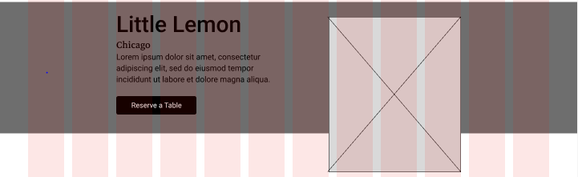

* Finally, work with the Highlights section.

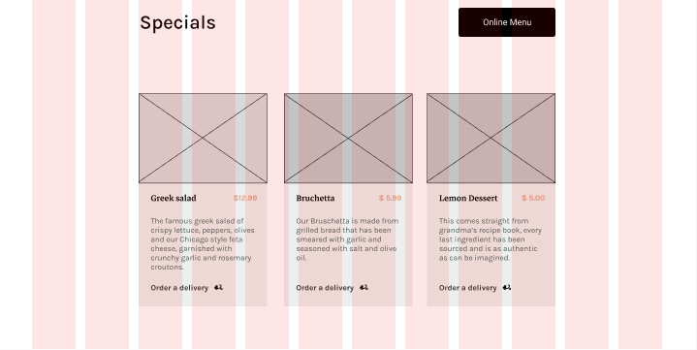

**Conclusion**

Well done! You should now have something similar to the following mock-up:

